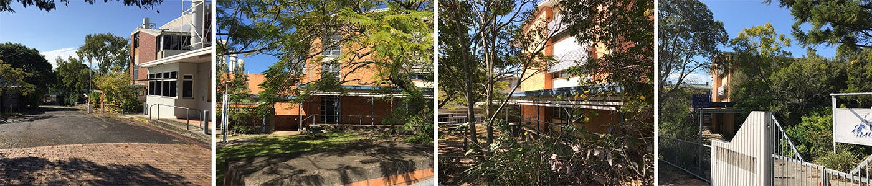

Construction Update December 2019
Works to demolish and remediate the former Yeronga TAFE site are now complete.

The contractor will soon begin removing all equipment and machinery from the site. Traffic control and signage will be in place to advise of any truck movements and to assist road users and pedestrians to move safely around the site during this time.

The site will then be hydro-mulched as a form of dust mitigation, which will be regularly monitored. Further hydro-mulch will be laid if required in the future.

We thank you for your patience while these works were completed. Our next update will be in early 2020, once a developer is appointed to undertake construction of the new mixed use precinct.

In the meantime, if you have any questions about this project, please contact us through the Have your Say website, or email edqengagement@dsdmip.qld.gov.au.

We wish you all a Merry Christmas and a happy and safe New Year.

Kind regards
The Yeronga Project Team

